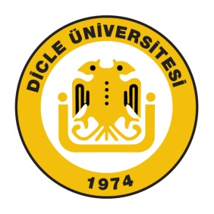

T.C.
DİCLE UNIVERSITY
OFFICE OF INTERNATIONAL AFFAIRS

Please fill in on computer except for dates

Dear Colleague;
This form is used to record the duration of the study of following student, while he/she is an Erasmus student at your institution. Thank you very much for your collaboration.

EU Office
CONFIRMATION OF ARRIVAL

This is confirm that

(first name and surname of student)
has arrived at,

(name of receiving institution)
on:
/ /

/ /
(date) (signature and stamp of the institution)

CONFIRMATION OF DEPARTURE
(to be filled at departure)

This is confirm that

(first name and surname of student)

the student of
DICLE UNIVERSITY

was following a course of studies at
(name of receiving institution)

has left:
/ /

/ /

(date) (signature and stamp of the institution)

Dicle Üniversitesi Yabancı Diller Yüksekokulu Ayrıntılı bilgi İçin: Uzm. Serkan EKMEN
Kat: 4 21280 DİYARBAKIR E-posta: euoffice@dicle.edu.tr
Tel: 0412 241 10 21, Fax: 0412 248 82 98 web: http://international.dicle.edu.tr/euoffice/index.htm

