- READING
- Read the text and answer the questions. Fill in the blanks with a name from the text. Use ('s) if necessary.
BEYAZ SHOW
I love this show. It is about famous people. The presenter of the programme is Beyazıt Öztürk. He is very funny. Today his guests are Kenan İmirzalıoğlu, Funda Arar and Gripin. Kenan İmirzalıoğlu is a very handsome actor. His new film is very nice. Funda Arar is my favourite singer. Her voice is great. Gripin is my brother's favourite band. It is a Turkish rock band. They are very good and their new CD is out now.
- .........Funda Arar.......... is a singer.
- ....................................is the presenter of the show.
- ....................................is a rock band.
- ....................................is about famous people.
- ....................................is a very nice handsome actor.
- ....................................is my brother's favourite band.
- ....................................new CD is out now.
- ....................................is very funny.

- Look at Bob's family tree, read the text and fill in the blanks with a family member word.

BOB'S FAMILY
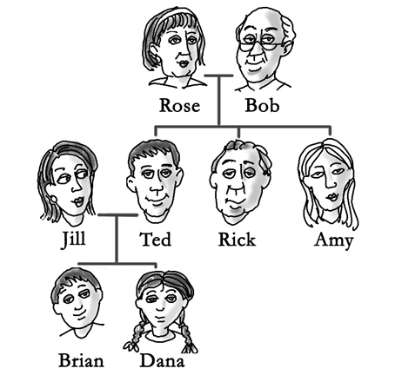
Bob has a nice family. Rose is his wife. They have a daughter and two sons. The daughter's name is Amy and the sons' names are Ted and Rick. Ted is married to Jill. They have got two children; Brian and Dana. Brian and his sister Dana are students. Their parents Ted and Jill are teachers.
Use these words: nephew, grandmother, son, mother, husband, aunt, brother.

- Ted is Dana's father and Jill is her ……………………..
- Dana is Jill's daughter. Brian is Jill's…………………….
- Brian is Dana's…………………….. She is his sister.
- Bob is Dana's grandfather and Rose is her……………………..
- Amy is Brian's…………………….and Rick is his uncle.
- Dana is Amy’s niece. Brian is her……………………..
- Bob is Rose's …………………….. Rose is his wife.

- Read the e-mail from Jill to her e-pal Mark and answer the questions below.
Dear Mark, Hello, I’m Jill from London-England. I’m a student .I'm ten years old. My mother's name is Mary. She is a teacher. She is thirty-six years old. My father is Adam. He is a taxi driver .I am an only child. I have got a cat and a dog. Their names are Max and Kitty. Max, the dog has got a small kennel in the garden. My cat, Kitty is 5 months old. Its basket is in my room. I have got three cousins. They are my uncle's children. My cousins have got a goldfish. Its name is Tiny. Their house is next to our house. I love my family and my pets very much. Hope to hear from you soon.
Love Jill.
- What is Jill's job? ...........................................................................................
- Who is Mary? ................................................................................................
- How old is her cat? ........................................................................................
- Where is the dog's kennel? ............................................................................
- Whose house is near Jill's house? ..................................................................
- Who is Max? ...................................................................................................
- Have her cousins got a fish or a horse? ..........................................................
- How many children has her uncle got? ……………………………………………………….

- VOCABULARY
- Fill in with a family member word.

- My mother's sister is my .......aunt...........
- My daughter's brother is my ..........................
- My father's daughter is my ..........................
- My mum and dad are my ..........................
- My sister's son is my ..........................
- My aunt's son or daughter is my..........................
- My father's brother is my ..........................
- My mother's father is my ..........................
- My daughter's son is my ..........................
- My brother's daughter is my ..........................

- Write down the term for the opposite sex.

- Mum - ........dad.............
- Brother - ...........................
- Son - ............................
- Uncle - ............................
- Grandmother -.......................
- Granddaughter -....................
- Nephew - ..........................
- Wife - ...........................
- Boyfriend - ..........................
- Cousin - .............................

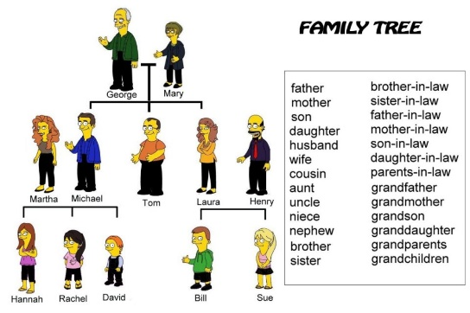
- Look at the family tree and write the relationships. Use the words from the box.

- Bill is Henry's..........son.................... .
- David is Mary's..................................
- Henry is George's............................. .
- Tom is Laura’s...................................
- Sue is Mary’s.....................................
- Martha is Michael’s............................
- David is Bill and Sue's.........................
- Mary is Martha’s................................ .
- Henry is Laura's...................................
- Tom is David's......................................
- Bill is Tom's.........................................
- Sue is Tom’s...................................... .

- GRAMMAR
- Fill in the blanks with a possessive adjective (my – his, etc. .....)
- I'm Harry. ......My........name is Harry.
- You are a tennis fan. ......................favourite sport is tennis.
- Look at this boy. ....................car is a Mercedes.
- Ali loves his mother. ........................name is Sally.
- İstanbul is very big. ........................population is over 14 million.
- We are teachers. .................students are little children.
- They are from Turkey. ......................house is in İzmir.

- Circle the correct words.
- This is my dog. (It) / (Its) name is Bony.
- Carlos and Maria are from Spain. (They) / (Their) are fifteen and (they)/ (their) favourite team is Barcelona.
- Helen and I are from Germany. (We ) / (Our) father is a driver.
- (I'm )/ (My) a Sting fan. (He's) / (His) music is very good.
- Survivor is (we're) / (our) favourite programme. (It )/ (Its) is very amazing.
- This is Jennifer. (She)/ (Her) is a dancer. (Her )/ (She) mother is a dancer, too.

- Rewrite the sentences. Use the possessive 's.
- Jane + book Jane's book
- My friend + dog .......................
- My family + house ........................
- John + car .........................
- Andrew + brother .........................
- Her sisters + names .........................
- Complete the sentences with possessive adjectives.
- That is my grandmother. _____Her_____ house is in Ankara.
- He is a tourist guide. …………………….. job is interesting.
- I'm a teacher. ……………………..students are very friendly.
- My grandparents are very rich. ……………………..house is very big.
- We are from Spain. ……………………..house is in Madrid.
- You aren't a nurse. What is ……………………..job?
- This is my cat. ……………………..name is Angel.
- Write if the ('s) is possessive or is.
- Sally's a good doctor. = ('s) = is
Sally's hair is brown. = ('s) = possessive.
- The cat's two years old. =..................................
The cat's tail is very long. =.................................
- Jennifer's father is in Japan. =.............................
Jennifer's in the kitchen. =...................................
- Ali's an engineer. = ............................................
Ali's boss is in China. =.......................................
- Martha's surname is Hanks. =.............................
Martha's ill today. =............................................
- My son's at school now. =....................................
My son's teacher is very good. =..........................
- Fill in the blanks using (his-her-its-our-their)

- Brian's cat ......his cat.......
- Jennifer's dog.........................
- The girl's room........................
- The girls' room........................
- Alan's and my car.....................
- The dog's kennel.......................
- Roy and Betty's cat....................
- Mr Green's house......................
- This boy's cat............................
- The children's pet....................

- WRITING
- Write a short paragraph about your family. Answer these questions.
- What is your father's name?
- What is his job?
- What is your mother’s name? What is her job?
- How many children have they got?
- How many sisters and brothers have you got? What are their names?
- Have you got a pet? If yes, what is it?
- Tell about other family members;(like your grandparents ,cousins, uncle ,....)
..............................................................................................................................................
................................................................................…...........................….........……...............................................................................:...................................:.........................................................................................................................................................................................................................................................................................................................................................................................................…......................................................................................................................................................................................................................

- TEST
GRAMMAR (1-10)
- My husband is a lawyer. .........salary is high.
A) My B) Her
C) His D) Its

- We are at home. ...........parents are on holiday.
A) You're B) You
C) We D) Our

- What is ............ grade in English exam?
A) your B) she
C) you D) she's

- .............a miner. ...........life is very difficult.
A) He's /He B) I'm / My
C) I'm /His D) He's /My

- Jennifer Lopez is a singer. ............... body is great.
A) My B) Your
C) Her D)Their

- A: What is ................... job?
B: They are pilots.
A) their B) your
C) they D) his

- A: Whose car is this?
B: It's .............. car.
A) my brother B) my brothers
C) my brother is D) my brother's

- Look at..............new car. .............is blue.
A) their/ It B) his / Its
C) its/ It D) they / Its

- Susan and Patty are in the music room. ................friends are in the gym.
A) She B) Their
C) She's D) They're

- Look at the colour of her hair. ............ is blue.
A) Its B) It
C) She D) Her

VOCABULARY (11-15)

- I'm Ali's sister. Ali is my ................ .
A) sister B) uncle
C) father D) brother

- My mother is my father's .............. .
A) wife B) parent
C) husband D) daughter

- I have got three ........... I'm their father.
A) parents B) brothers
C) children D) uncles

- My father and mother are my .............. .
A) children B) parents
C) grandparents D) son

- My sister's daughter is my .................. .
A) cousin B) parent
C) niece D) nephew

READING (16-20)

Read the text and find if the sentences are TRUE or FALSE (16-20 QUESTIONS)

Dear Sandra,

I'm Lucy from America. I’m sixteen years old and I'm a student at high school. My father's name is James .He's forty and he's an engineer. His favourite sport is basketball. My mother's name is Brenda and she's forty, too. She's a housewife but she's always busy. I have got two brothers. Their names are Ben and Tom. They are three years old. I love my family very much. What about you? Write to me soon.

Best wishes,
Lucy

- Lucy is a university student.
A) TRUE B) FALSE

- Lucy's parents are engineers.
A) TRUE B) FALSE

- Brenda has got three children.
A) TRUE B) FALSE

- Sandra is Ben and Tom's sister.
A) TRUE B) FALSE
- Ben and Tom are little children.
A) TRUE B) FALSE

GOOD LUCK!

F. ANSWER KEY
A. READING (1)

- Beyazıt Öztürk
- Gripin.
- Beyaz Show
- Kenan İmirzalıoğlu
- Gripin
- Gripin’s
- Beyazıt Öztürk

A. READING (2)

- mother
- son
- brother
- grandmother
- aunt
- nephew
- husband

A. READING (3)

- She is a student.
- She is Jill's mother.
- It is 5 months old.
- It is in the garden.
- Her cousins' house.
- It is Jill's dog.
- They have got a dog.
- He has got 3 children.

B. VOCABULARY (1)

- son
- sister
- parents
- nephew
- cousin
- uncle
- grandfather
- grandson
- niece

B. VOCABULARY (2)

- sister
- daughter
- aunt
- grandfather
- grandson
- niece
- husband
- girlfriend
- cousin

B. VOCABULARY (3)

- grandson
- son -in-law
- brother
- granddaughter
- wife
- cousin
- mother-in-law
- husband
- uncle
- nephew
- niece

C. GRAMMAR (1)

- your
- his
- her
- its
- our
- their

C. GRAMMAR (2)

- Its
- They/their
- Our
- I'm/His
- Our/it
- she/her

C. GRAMMAR (3)

- Jane's book
- my friend's dog
- my family's house
- John's car
- Andrew's brother
- her sisters' names

C. GRAMMAR (4)

- his
- my
- their
- our
- your
- its

C. GRAMMAR (5)

- ('s)=is ('s)=possessive
- ('s)=possessive ('s)=is
- ('s)=is ('s)=possessive
- ('s)=possessive ('s)=is
- ('s)=is ('s)=possessive

C. GRAMMAR (6)

- her dog
- her room
- their room
- our car
- its kennel
- their cat
- his house
- his cat
- their pet

D. WRITING
E. TEST

- C
- D
- A
- B
- C
- A
- D
- A
- B
- B
- D
- A
- C
- B
- C
- B
- B
- A
- B
- A

