1. **READING**
2. **Read the information about three hotels, and answer the questions. Which hotel are the people staying at? Write *Plaza*, *Park* or *Roxy*. The first question has been done for you.**

**THE ROXY HOTEL**

The Roxy Hotel is near the airport, about 10 km from the city. It has 120 rooms on seven floors, and six lifts. There is a restaurant and a swimming pool. The rooms are not very large, but all have bathrooms, and some rooms have small balconies. There is a phone, TV and radio in every room.

**THE PARK HOTEL**

The Park Hotel is in the city centre. It has 25 rooms on four floors. There is not a lift. The rooms are small, but they have big windows, and there is a desk and chair, and a radio. There are two bathrooms on every floor, and there is a TV room next to the restaurant, on the ground floor.

**THE PLAZA HOTEL**

The Plaza Hotel is right on the beach. All rooms have their own bathroom, phone and TV. They also have a large bed, a sofa and two armchairs, and a large balcony. There are 60 rooms on five floors, and four lifts. The hotel has three restaurants and two swimming pools.

**Example:** There isn’t a lift in our hotel. ......Park.......

1. We have a balcony, but it isn’t very big. ....................
2. Our room has a TV, but not a radio. ....................
3. The hotel’s near all the big shops. ....................
4. The restaurants in our hotel are very good. ....................
5. The rooms are very large. ....................
6. Our room is on the sixth floor. ....................
7. There isn’t a toilet or a shower in our room. ....................
8. The hotel’s by the sea. ....................
9. **Read the story. Then answer the questions below.**

**My Friend**

I have a friend. My friend lives in California. My friend is a girl. She is seventeen years old. Her name is Jessica Roberts. Jessica is cool. I like her a lot. She likes to read. She is a good reader. She is good at math too. It is her best subject. Jessica is smart. I like to eat lunch with her. We eat lunch on Monday, Tuesday, and Wednesday. Jessica is my friend.

1. Where does my friend live?

**A.** Colorado

**B.** Texas

**C.** California

1. Is my friend a girl or a boy?

**A.** She is a girl.

**B.** He is a boy.

1. How old is my friend?

**A.** 15 years old

**B.** 16 years old

**C.** 17 years old

1. What is my friend’s name?

**A.** Jenny

**B.** Jessica

**C.** Julia

1. What is my friend’s last name?

**A.** Rowan

**B.** Randal

**C.** Roberts

1. What is Jessica’s best subject?

**A.** English

**B.** Math

**C.**Science

1. **Read Cécile’s letter and answer the questions below.**

*12 Via Verdi*

*Bologna, Italy*

*Dear Fabio,*

*Hello! How are you? I’m fine. I’m in Bologna, at the Bologna Institute of Italian. I am in class D4 with 10 other students. They’re from different countries - Russia, Mexico, Hungary and Greece. Our teacher’s name is Antonella Mastroanni. She is not very nice. She is serious and cold.*

*My address is at the top of the letter. I am in a dormitory with the other students. They are friendly and it is easy to understand them. Bologna is small and interesting. The weather is bad – cold and rainy – but the forest is beautiful.*

*The buses are cheap but the taxis are expensive. Italian food is lovely and Italian hot chocolate is superb!*

*See you in Valencia soon!*

*With love, Cécile*

1. Who is Fabio? Where is he? ................................................................................................
2. Where is Cécile? ................................................................................................
3. Which countries are Cécile’s classmates from? .......................................................................
4. What is her teacher’s surname? ..............................................................................................
5. Is Antonella funny? ................................................................................................
6. Are the other students in the dormitory friendly? ...................................................................
7. Is the weather cold and sunny? ................................................................................................
8. Is the forest beautiful? ................................................................................................
9. Are the buses and taxis cheap? ................................................................................................
10. Is the Italian food horrible? ................................................................................................
11. **VOCABULARY**
12. **Find 7 countries names, and 7 nationalities in the square.**

#### They are

|  |  |  |  |  |  |  |  |  |  |  |  |  |
| --- | --- | --- | --- | --- | --- | --- | --- | --- | --- | --- | --- | --- |
| F | E | C | E | E | S | C | H | I | T | I | S | H |
| R | H | C | N | E | R | F | H | B | R | G | R | E |
| E | J | A | P | N | E | N | R | I | E | F | R | A |
| N | N | T | U | G | U | A | K | R | N | P | U | Z |
| G | I | N | E | L | Z | S | M | A | I | A | S | E |
| H | A | I | T | I | T | A | L | I | A | N | S | Z |
| S | T | A | L | S | N | Y | J | A | I | E | P | I |
| I | G | T | R | H | G | Y | C | P | N | B | A | L |
| T | R | I | B | C | H | I | E | A | A | T | I | U |
| T | G | R | E | E | C | E | P | K | E | J | N | T |
| O | E | B | T | A | N | A | C | I | R | E | M | A |
| C | B | R | N | E | J | U | K | S | G | U | F | R |
| S | J | Z | D | N | A | L | E | R | I | C | T | H |

**Countries Nationalities**

**.............................. ..............................**

**.............................. ..............................**

**.............................. ..............................**

**.............................. ..............................**

**.............................. ..............................**

**.............................. ..............................**

**.............................. ..............................**

1. **The Alphabet**

**Remember**

A B C D E F G H I J K L M N O P Q R S T U V W X Y Z

**Write the words in alphabetical order**

1. Radio 1. ............. Atlas ..............
2. Television 2. ....................................
3. Hamburger 3. ....................................
4. Video 4. ....................................
5. Taxi 5. ....................................
6. Jeans 6. ....................................
7. Pizza 7. ....................................
8. Computer 8. ....................................
9. Book 9. ....................................
10. Music 10. ....................................
11. Football 11. ....................................
12. Tennis 12. ....................................
13. Volleyball 13. ....................................
14. Basketball 14. ....................................
15. Film 15. ....................................
16. Photography 16. ....................................
17. Atlas 17. ....................................
18. Yoghurt 18. ....................................
19. Kilometre 19. ....................................
20. Electricity 20. ....................................
21. **Match the words with the pictures**

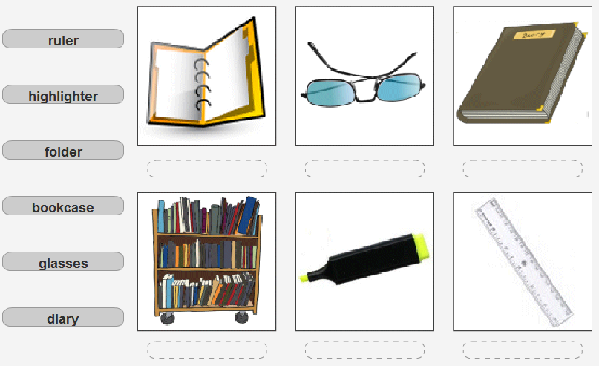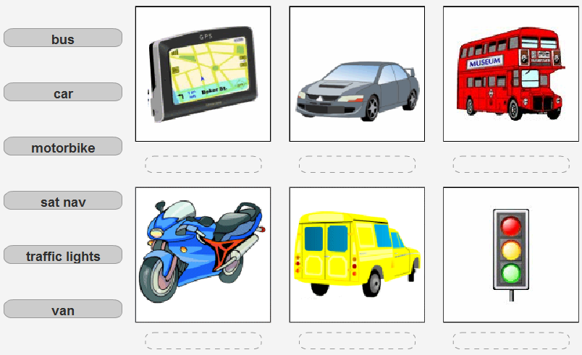

1. **GRAMMAR**
2. **Complete the conversations.**

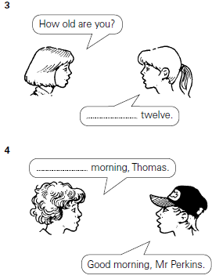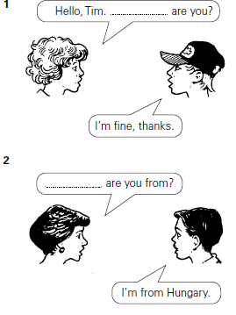

1. **Match the sentences**

|  |  |
| --- | --- |
| 1.      What’s your name ? | a. ...... Hello |
| 2.      How old are you ? | b. ...... I am English |
| 3.      What’s your nationality ? | c. ...... I am twelve years old |
| 4.      Hello | d. ...... I am from England |
| 5.      Where are you from ? | e. ...... I am fine |
| 6.      How are you ? | f. ...... My name is Tom |

1. **Put the conversation in order**



1. **Put *am*, *is*, or *are* in the gaps.**

**Example**: Alan  *is*  a doctor.

1. My name ................... Ahmet.



1. I ................... from Istanbul.
2. Ayşe ................... from Antalya.
3. His name ................... Mehmet.
4. They ................... students.
5. John and Mary ................... teachers.
6. We ................... from Turkey,
7. I ................... a student.
8. Mary and Sue ................... sisters.
9. I ................... twenty.
10. **Put *I*, *she / he*, or *you*, in the gaps.**

**Example**: Your sister is a doctor. ***She*** is from Ankara.

1. I have a brother. ................... is fifteen.
2. ................... am English.
3. You live in Istanbul, and ................... are Turkish.
4. My sister is married; ................... is a doctor. ................... is twenty-five.
5. Where are ................... from?
6. My mother is a teacher; ................... is from Adana.
7. Where am ................... from?
8. Your brother is a student; where is ................... from?
9. **Write the questions for these answers.**

***Example****: ...........* ***What’s your name*** *..........? My name’s Alice.*

1. ..........................................................? I’m from Turkey.
2. ..........................................................? She’s nineteen.
3. ..........................................................? He’s a doctor.
4. ..........................................................? D-I-C-T-I-O-N-A-R-Y.
5. ..........................................................? Fine, thanks.
6. ..........................................................? Her name is Gül.
7. ..........................................................? 0212 538 6721
8. **Put the words in the right order to make a sentence.**

**Example**: is / name / Paula / my. ..... My name is Paula. ......

1. surname / her / is / Smith. ...............................................................
2. am / England / I / from. ...............................................................
3. from / is / where / she ? ...............................................................
4. your / job / is / what ? ...............................................................
5. do / spell / it / how / you ? ...............................................................
6. an / is / dictionary / it / English. ...............................................................
7. this / English / what / is / in ? ...............................................................
8. doctor / he / a / is. ...............................................................
9. first / how / your / spell / name / do / you ? ...............................................................
10. eighteen / am / old / I / years. ...............................................................
11. **Fill in the blanks using “HE, SHE, IT, WE, YOU, THEY”:**
12. Cat and horse ……....……
13. Jack and I ……....……
14. You and Dave ……....……
15. Cheese ……....……
16. Pamela ……....……
17. Geese ……....……
18. School ……....……
19. Children ……....……
20. Bicycle ……....……
21. Son ……....……
22. Shop ……....……
23. Mr. Green ……....……
24. Friendship ……....……
25. Love ……....……
26. **WRITING**
27. **Write short sentences**

**Example**: (Chris, 9, student, short, not Chinese)

.......... Chris is nine years old. He is a student. He is short. He isn’t Chinese. ........

1. (Leonard and Mike, 25, firemen, tall, American)

..........................................................................................................

1. (Patty and Brian, 12, not electrician, short, not Turkish children)

..........................................................................................................

1. (Natalie and I, nurse, not tall, French)

..........................................................................................................

1. (Mark, 19, accountant, short, British)

..........................................................................................................

1. (Cengiz, 23, lieutenant, not blonde, Turkish)

..........................................................................................................

1. **Write answers to the questions in paragraph**
2. What is your name?
3. Where are you from?
4. Where do you live?
5. Why are you here (in this city)?
   1. Are you a student? If yes, what are you studying?
   2. Do you work? If yes, what is your job?
6. What do you like to do in your free time? What are your hobbies?
7. What are your three favourite books?
8. Describe your first day in this class

..........................................................................................................................................................

..........................................................................................................................................................

..........................................................................................................................................................

..........................................................................................................................................................

..........................................................................................................................................................

..........................................................................................................................................................

..........................................................................................................................................................

..........................................................................................................................................................

..........................................................................................................................................................

1. **Test**

**GRAMMAR (1-10)**

1. **George**: …………….? **Fred**: Fifty-six.

A) How old are you?

B) Where are you from?

C) What nationality are you?

D) How are you?

1. I ………. 26 years old, but Andy ……… 30.

A) am / am B) are / am

C) am / is D) are / are

1. Luigi and I ……….from Rome. …….. are Italian.

A) is / They B) are / We

C) am / We D) am / You

1. **Nicholas**: What ……… are you?

**Teresa**: I am Bulgarian. I am ……

Bulgaria.

* + 1. old / fine
    2. country /nationality

C) old / nationality

D) nationality / from

1. Tony and Lisa are ……..... . They are from the ……… .

A) Japan / Japanese

B) Greek / Greece

C) Turkey / Turkish

D) American / USA

1. **Bruce**: ……………….. .

**Brian**: Not bad, and you?

A) Are you from Russia?

B) How old are you?

C) How are you?

D) What nationality are you?

1. Jean-Louis and I ………. from Paris. …….. are French.
   * 1. are / We B) is / They

C) am / We D) am / You

1. ........... are very happy today.

A) She B) We

C) My D) Their

1. Shogun and Hanako are from …. . They are ….… .

A) Greek / Greece

B) American /The USA

C) Turkish / Turkey

D) Japan / Japanese

1. What nationality is he?

A) He is ten years old.

B) He lives in Germany.

C) He is German.

D) He is a student.

**VOCABULARY (11-15)**

1. Japan and Spain are ……….

A) country B) months

C) countries D) nationalities

1. easy - ______

A) cold B) cheap

C) difference D) difficult

1. fast - ______

A) small B) slow

C) quick D) warm

1. expensive - ______

A) big B) cheap

C) cold D) hot

1. hot - ______

A) cold B) new

C) warm D) small

**READING (16-20)**

My name is Tracy Fordham. I'm twenty-nine years old. I come from Mexico. My nationality is Mexican. I can speak Spanish, English and a little Portuguese. I am studying English at college. I am a waiter too. I have lived in England for three years.

1. Where does Tracy come from?

A) England B) Mexico C) Portugal D) Italy

1. What is Tracy studying at college?

A) Brazilian B) Portuguese C) English D) Italian

1. What is her nationality?

A) Mexican B) English

C) Portuguese D) Russian

1. How old is Tracy?

A) 19 B) 39

C) 18 D) 29

1. How many languages can Tracy speak?

A) 3 B) 5

C) 4 D) 2

**GOOD LUCK**

**F. ANSWER KEY**

**A. READING (1)**

1. Roxy
2. Plaza
3. Park
4. Plaza
5. Plaza
6. Roxy
7. Park
8. Plaza

**A. READING (2)**

1. C
2. A
3. C
4. B
5. C
6. B

**A. READING (3)**

1. Fabio is Cécile’s friends and he is in Valencia.
2. She is in Bologna, Italy.
3. They are from Russia, Mexico, Hungary and Greece.
4. It is Mastroanni.
5. No, she isn’isn’t.
6. Yes, they are.
7. No, it isn’t.
8. Yes, it is.
9. The buses are cheap but the taxis are expensive.
10. No, it isn’t. Italian food is lovely.

**B. VOCABULARY (1)**

**Countries :** Greece – Britain – Turkey – Spain – Ireland – China – Brazil

**Nationalities:** Italian – English – Scottish – French – German – Japanese – American

**B. VOCABULARY (2)**

1. Atlas
2. Basketball
3. Book
4. Computer
5. Electricity
6. Film
7. Football
8. Hamburger
9. Jeans
10. Kilometre
11. Music
12. Photography
13. Pizza
14. Radio
15. Taxi
16. Television
17. Tennis
18. Video
19. Volleyball
20. Yoghurt

**B. VOCABULARY (3)**



ruler

bookcase

highlighter

glasses

diary

folder

Traffic

Lights

van

motorbike

bus

car

sat nav

**C. GRAMMAR (1)** 1. How 2. Where 3. I am 4. Good

**C. GRAMMAR (2)**

1. F
2. C
3. B
4. A
5. D
6. E

**C. GRAMMAR (3)**

1. 1
2. 6
3. 3
4. 2
5. 5
6. 4
7. 7

**C. GRAMMAR (4)**

1. is
2. am
3. is
4. is
5. are
6. are
7. are
8. am
9. are
10. am

**C. GRAMMAR (5)**

1. He
2. I
3. you
4. she-she
5. you/they
6. she
7. I
8. he

**C. GRAMMAR (6)**

1. Where are you from?
2. How old is she?
3. What is his job?
4. How do you spell “dictionary”?
5. How are you?
6. What is her name?
7. What is your phone number?

**C. GRAMMAR (7)**

1. Her surname is Smith.
2. I am from England.
3. Where is she from?
4. What is your job?
5. How do you spell it?
6. It is an English dictionary.
7. What is this in English?
8. He is a doctor.
9. How do you spell your first name?
10. I am eighteen years old.

**C. GRAMMAR (8)**

1. They
2. We
3. You
4. It
5. She
6. They
7. It
8. They
9. It
10. He
11. It
12. He
13. It
14. It

**D. WRITING (1)**

**E. Test**

1. A
2. C
3. B
4. D
5. D
6. C
7. A
8. B
9. D
10. C
11. C
12. D
13. B
14. B
15. A
16. B
17. C
18. A
19. D
20. A

**GOOD LUCK**