1. **READING**

**Read And Answer The Questions**

Right now, it is Monday morning. Mike and Tina are at home. They are sitting at a table. They are eating breakfast. At this moment, Tina is drinking coffee and eating a sandwich. She is sitting across the table from Mike. She is talking to Mike.

Mike is Tina's husband. He is sitting at the table with Tina. He is also drinking coffee. Mike is listening to Tina. After breakfast, Mike and Tina are leaving for work. They work in the city. They are going to work by bus.

1. Where are Mike and Tina on Monday morning? What are they doing? ................................................................................................
2. Where is Tina sitting now? What is Tina eating?

................................................................................................

1. Where are Mike and Tina going after breakfast? How are they getting there? ................................................................................................

**Read And Answer The Questions**

Now Janet is in her house. She is sitting on a wooden chair. She is holding a coat. She is fixing it. James is Janet’s husband. He is sitting in front of her. He is fixing clothes too.

Elizabeth is sitting next to James. She is Janet's sister. Right now she is helping Janet and James. They are working together. They are fixing clothes. At this moment a man is coming in. He is wearing dark clothes. He is carrying a pile of clothes. They are all working very hard.

1. Where is Janet sitting now? What is she doing?

................................................................................................

1. Where is James sitting now? What is he doing?

................................................................................................

1. Who is coming in at this moment? What is he carrying? ................................................................................................
2. **VOCABULARY**

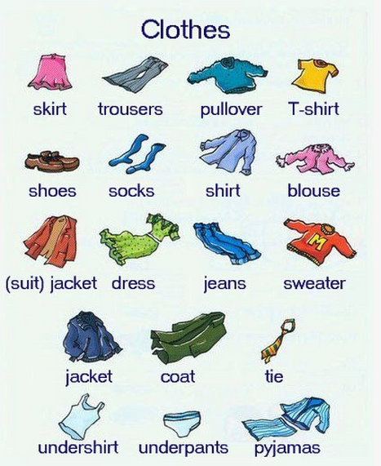

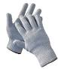gloves 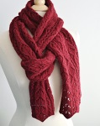 scarf 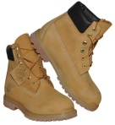boot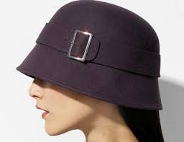 hat 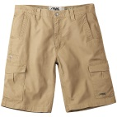 shorts  high heels

1. **What are the names of the clothes below**
2. An outer covering for the human foot, normally made of leather (but often of other materials)………………
3. We wear them before going to bed……………….
4. Scottish men wear a special …………
5. It is a set of garments made from the same cloth, usually consisting of at least a jacket and trousers………..
6. A long piece of cloth worn around the neck or shoulders………….
7. Lewis and Wranglers are ……………..
8. We wear them on our feet under footwear………………..
9. We wear them to keep our hands warm in especially in winter…………
10. It is a piece of [fabric](http://en.wikipedia.org/wiki/Fabric) worn around the neck, or near the [head](http://en.wikipedia.org/wiki/Human_head) or around the [waist](http://en.wikipedia.org/wiki/Waist) for warmth, cleanliness, [fashion](http://en.wikipedia.org/wiki/Fashion) or for [religious](http://en.wikipedia.org/wiki/Religion) reasons………………
11. **Odd One Out**
12. jacket – coat – shoes
13. pyjamas – sweater – blouse
14. trousers – socks – jeans
15. shoes – socks – tie
16. T-shirt – undershirt – underpants
17. pullover – sweater – T-shirt
18. **Match the words with the pictures**

**1.** train **2.** car **3.** ship **4.** fire engine **5.** taxi **6.** Bicycle  **7.** tricycle

**8.** jet ski **9.** balloon **10.** van **11.** bus **12.** lorry **13.** sail boat **14.** ambulance

**15.** plane **16.** speed boat **17.** police car **18.** jeep **19.** motorbike **20.** helicopter

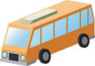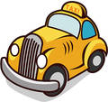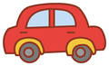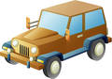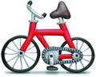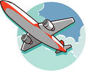(…2...) (………) (………) (………) (………) (………) (……….)

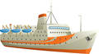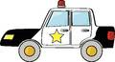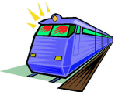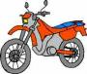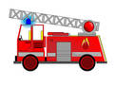(…..…..) (…..…..) (…..…..) (……....) (…..…..) (…..…..) (………..)

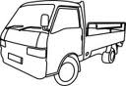[](http://www.hasslefreeclipart.com/clipart_transportation/boat_sail.html)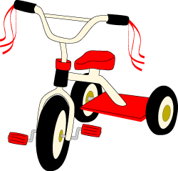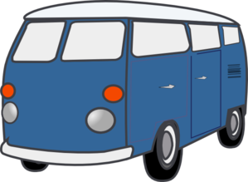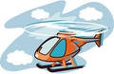(………) (……....) (……….) (….7.…) (……….) (………)

**4. Complete the table grouping the means of transports according to the place:**

|  |  |  |  |
| --- | --- | --- | --- |
| land transport |  |  |  |
|  |  |  | air transport |
|  |  | water transport |  |
|  |  |  |  |
|  |  |  |  |
|  |  |  |  |

1. **Match the pictures with the words below**

train station – bus station – port – airport

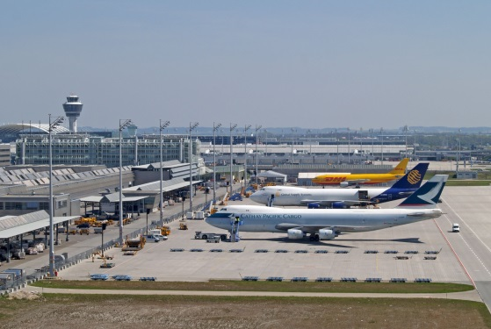  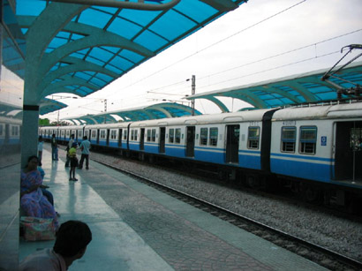

**1 ________________________________ 2 ________________________________**

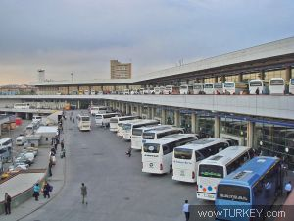  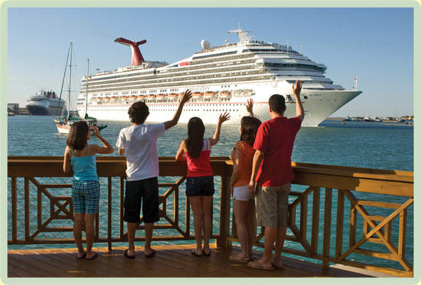

**3 ______________________________ 4 ________________________________**

**6. Circle the odd one out.**

**1**. car, bus, plane, bicycle.

**2**. plane, ship, helicopter, balloon.

**3**. parachute, ship, speed boat, jet ski.

**4**. lorry, taxi, train, van.

**5**. police car, fire engine, ambulance, ca

1. **GRAMMAR**
2. **Make negative & positive sentences**
3. (she / now / drive to school)  …………………………………………………………………..……………………
4. (I / work / now) …………………………………………………………………..……………………
5. (Joe/ not / study )  …………………………………………………………………..……………………
6. (Jane / not /play basketball tonight)  …………………………………………………………..……………………
7. (we / listen to music)  …………………………………………………………………..……………………
8. (she / not / study in Italy)  …………………………………………………………………..……………………
9. (Jane / not / wait for the bus)  …………………………………………………………………..……………………
10. (they / read)  …………………………………………………………………..……………………
11. (we / not / go to the cinema tonight) ………………………………………………………..……………………
12. (you / not / read the newspaper) ………………………………………………………..……………………
13. (she / eat chocolate)  …………………………………………………………………..……………………
14. (I / not / travel to Zurich)  …………………………………………………………………..……………………
15. (we / study Spanish)  …………………………………………………………………..……………………
16. (my parents / not / leave now)  …………………………………………………………………..……………………
17. (Paul / live in New York)  …………………………………………………………………..……………………
18. (she / work in a restaurant now) …………………………………………………………………..……………………
19. (I / not / meet my mother at six) …………………………………………………………………..……………………
20. (she / not / drink tea now) …………………………………………………………………..……………………
21. (she / play the piano) …………………………………………………………………..……………………
22. (we / not / cook)  …………………………………………………………………..……………………
23. **Underline or circle the correct one (Present Continuous or Simple Present?)**

**Example**: I am working / work hard nowadays.

1. Look! John is coming **/** comes here
2. My father always goes **/** is always going to bed early.
3. His children watch **/** are watching TV at the moment.
4. I like **/** am liking tea.
5. We go **/** are going on a picnic this Saturday.
6. Jane is giving **/** gives a a party on her birthdays.
7. Can you hear? Somebody is knocking **/** knocks at the door.
8. John is waiting **/** waits for his wife at the airport now.
9. They look **/** are looking for their ball right now but they can’t find it.
10. He is often visiting **/** often visits his relatives on Bairams.
11. **Make Questions**
12. You / learn / a new tense …………………………………………………………………………………….. ?
13. teacher / your / teach / you / a new tense …………………………………………………………….. ?
14. Alice / study / English ………………………………………………………………………………….. ?
15. father / your / read / his newspaper / at the moment ……………………………………………………….. ?
16. The students / in the garden / play /football …………………………………………………………………….. ?
17. My father / sleep / at the moment …………………………………………………………………………….. ?
18. John and Jane / have breakfast / on the balcony ……………………………………………………….. ?
19. you / do / homework / now …………………………………………………………………………………….. ?
20. the dishes / Susan’s mother / wash …………………………………………………………………………….. ?
21. the roses / your grandmother / water / in the garden ……………………………………………………….. ?
22. Jane’s sister / cooking / now / in the kitchen …………………………………………………………………….. ?
23. on the street / Sue / run ………………………………………………………………………….. ?
24. Alice / study / nowadays / very hard …………………………………………………………………………….. ?
25. he / try to / his foreign / improve / language / this year ……………………………………………………….. ?
26. Jane / a new job / look for / this term ……………………………………………………………………………….. ?
27. **Wh-Questions – Choose One**
28. Where / What / Which are you going?
29. What time / When / How is the film starting?
30. Which / What / When is Jane leaving from İstanbul?
31. How / Why / Which is your little brother crying?
32. Where / How / What is it going with you?
33. When / What / Who are they doing in the garden?
34. Who / Where / How are you waiting for me now?
35. Why / Which / Who are you disturbing your friends in the class during the lesson?
36. Why / What time / What are you fighting instead of listening to each other?
37. Why / What / Which are you cooking for dinner?
38. **WRITING**

**Write about what are you and your friends or family members doing now. (100 words minimum)**

**………………………………………………………………………………………………………………………………………………….**

**………………………………………………………………………………………………………………………………………………….**

**………………………………………………………………………………………………………………………………………………….**

**………………………………………………………………………………………………………………………………………………….**

**………………………………………………………………………………………………………………………………………………….**

**………………………………………………………………………………………………………………………………………………….**

**………………………………………………………………………………………………………………………………………………….**

**………………………………………………………………………………………………………………………………………………….**

**………………………………………………………………………………………………………………………………………………….**

**………………………………………………………………………………………………………………………………………………….**

**………………………………………………………………………………………………………………………………………………….**

1. **TEST**

**Choose the Correct Answer**

**GRAMMAR (1-15)**

1. We _____ watching a good documentary _____ TV now.

A) are / in B) am / on

C) are / on D) is / in

1. I always __________by credit card.

A) pay

B) am paying

C) ’m paying

D) pays

1. _____ is reading a letter _____ bed now.

A) She / in B) I / in

C) You / on D) He / at

1. A: What _____ you _____?

B: I’m an engineer.

A) do / do B) are / do

C) is / do D) do / doing

1. A: What _____ she ____ now?

B: I don’t know.

A) does / do B) do / do

C) is / doing D) is / do

1. A: _____ are we _____?

B: To the class.

A) When / going

B) Where / go

C) When / go

D) Where / going

1. A: Oh no! It _____. We can’t go out.

B: It always _____ here in March.

A) is snowing / snows

B) snows / ’s snowing

C) ’s snow / snows

D) snows / snows

1. I _____. Because it’s my happiest day today.

A) jumping B) jump

C) ’m jumping D) jumped

1. Benedit and Nina are ____ only salads. Because vegetarians don’t _____ meat.

A) eat / eat B) eating / eating

C) eat / eating D) eating / eat

1. Sorry, I _____ understand you. I _____ speak Russian.

A) do / don’t B) do / do

C) don’t / don’t D) am / am

**VOCABULARY (11-15)**

1. It is raining outside now. So I am wearing my _____.

A) raincoat B) tie

C) shoes D) jacket

1. It is very hot outside. Joe is wearing his t-shirt and _____

A) socks B) shorts

C) sweater D) blouse

1. Shelia is on the plane. She is flying from Finland to Belgium at the moment. Her father is waiting for her at the_____ .

A) station B) port

C) airport D) train station

1. A: What are you doing?

B: I am calling a /an _____ because my neighbor is having a heart attack right now.

A) police car B) ambulance

C) lorry D) plane

1. I am waiting for my daughter at the port because she is coming here by____.”

A) ship B) plane

C) bus D) train

**READING (16-20)**

It’s a rainy Saturday. It’s raining a lot and Mary and her family are spending the afternoon at home. Her uncles are visiting them. Mary and her father are in the living room. Mary is drawing a picture and her father, Mr. Harris is surfing in the internet. They are also chatting. Mary’s older brother, Peter, is in his bedroom playing computer games. He is a computer fanatic and he spends much time playing on the computer. His little brother, Jim is also in the living room. He is playing with his dinosaurs’ collection. Mary’s mother, Mrs. Harris, is in the kitchen making a cake for the guests. Also, she is making some tea and talking to Mary’s uncles – Lucy and Tom. They are from the nearest town and stopped by to say hello. Paka, the family cat, is sleeping on the kitchen’s sofa.

1. Who is playing with toys?

A) Mary B) Tom

C) Jim D) Peter

1. Marry is drawing a picture and ……….with her father.

A) surfing in the internet

B) chatting

C) playing computer games

D) sleeping in the bedroom

1. Who are visiting them? Who are the guests at home?

A) Mary’s brothers

B) Mary’s parents

C) Mary’s uncles

D) Mary’s cat

1. A: Why are they spending the afternoon at home?

B: Because ……………………………

A) They are sitting at home

B) Mary’s parents are in the living room

C) Mary’s uncles are visiting them

D) It is raining

1. Is the family cat spending time with Mary?

A) Yes, it is.

B) No, it isn’t.

C) Because it is eating cake.

D) Because it is sleeping.

**GOOD LUCK!**

1. **ANSWER KEY**
2. **READING**
3. **Read And Answer The Questions**
4. They are at home. They are having breakfast.
5. She is sitting across the table from Mike. She is drinking coffee and eating a sandwich.
6. They are going to work after breakfast. They are going to work by bus.
7. **Read And Answer The Questions**
8. She is sitting on a wooden chair. She is holding a coat and fixing it.
9. He is sitting in front Janet. He is fixing clothes too.
10. A man is coming in. He is carrying a pile of clothes.
11. **VOCABULARY**
12. **What are the names of the clothes below**
13. Shoes 2- pyjamas 3- skirt 4- suit 5- tie 6- jeans 7- socks 8- gloves 9- scarf
14. **Odd One Out**
15. Shoes 2- pyjamas 3- socks 4- tie 5- T-shirt 6- T-shirt
16. **Match the words with the pictures**

**(…2...) (…18…) (…15…) (…5…) (…6…) (..11…) (…8….)**

**(…16.) (….17..) (…1..) (……14..) (….19..) (….4…..) (…3…..)**

**[](http://www.hasslefreeclipart.com/clipart_transportation/boat_sail.html)(…20…) (…10....) (…9….) (….7.…) (…13….) (…12…)**

1. **Complete the table grouping the means of transports according to the place:**

|  |  |  |  |
| --- | --- | --- | --- |
| **land transport** | tricycle | jeep | Speed boat |
| train | van | motorbike | **air transport** |
| car | bus | **water transport** | ballon |
| Fire engine | lorry | ship | plane |
| taxi | ambulance | jet ski | helicopter |
| bicycle | police car | Sail boat |  |

1. **Match the pictures with the words below**

1– airport 2- train station 3– bus station 4 – port

**6- Circle the odd one out**

1- Plane 2- Ship 3- Parachute 4- Train 5- car

1. **GRAMMAR**
2. **Make negative & positive sentences**
3. She is driving to school now
4. I’m working now
5. Joe isn’t studying
6. Jane isn’t playing basketball tonight.
7. We aren’t listening to music
8. She isn’t studying in Italy
9. Jane isn’t waiting for the bus
10. They are reading
11. We aren’t going to the cinema tonight
12. You aren’t reading the newspaper
13. She isn’t eating chocolate
14. I am not travelling to Zurich
15. We aren’t studying Spanish
16. My parents aren’t leaving now
17. Paul isn’t leaving in New York
18. She is working in a restaurant now
19. I am not meeting my mother at six
20. She isn’t drinking tea now
21. She isn’t playing the piano
22. We aren’t cooking
23. **Underline or circle the correct one (Present Continuous or Simple Present?)**
24. is coming 2- always goes 3- are watching 4- like 5- are going

6- gives 7- is knocking 8- is waiting 9- are looking 10- often visits

1. **Make Questions**
2. Are you learning a new tense?
3. Is your teacher teaching you a new tense?
4. Is Alice studying English?
5. Is your father reading his newspaper at the moment?
6. Are the students playing football in the garden?
7. Is your father sleeping at the moment?
8. Are John and Jane having breakfast on the balcony?
9. Are you doing homework now?
10. Is Susan’s mother washing the dishes?
11. Is your grandmother watering the roses it the garden?
12. Is Jane’s sister cooking in the kitchen?
13. Is Sue running on the street?
14. Is Alice studying very hard nowadays?
15. Is he trying to improve his foreign language this year?
16. Is Jane looking for a new job this term?
17. **Wh-Questions – Choose One**
18. Where 2- What time 3- When 4- Why 5- How 6- What 7- Where 8- Why 9- Why 10- What

1. **WRITING**

**……………………………………..**

1. **TEST**

**Choose the Correct Answer (Present Continuous or Simple Present?)**

1. C 2- A 3- A 4- A 5- C 6- D 7- A 8- C 9- D 10- C

11- A 11- B 13- C 14- B 15- A 16- C 17- B 18- C 19- D 20- B