- READING
- Look at the picture and guess what is the text about!
- body b) colours c) life
ME, MYSELF
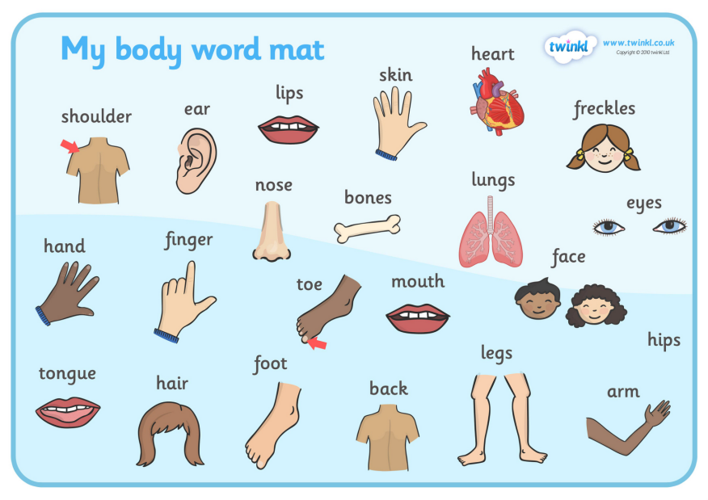
Hello, my name is Robin. Human body is so great. Today I want to tell something about my body. I’m 13 years old. So, I have got a small body. I have got blue eyes, long strait, hair. My head is a bit big. I have got two big ears. They are funny. My nose is small but my mouth is large. I’ve got long arms and long legs. So, I can play basketball well. Until now everything about my body is normal. But there is something interesting with my toes. I have got six toes on my right foot. Weird huh? Have you got anything interesting with your body?
- Answer the questions.
- Has Robin got blue eyes?
______________________
- Is his head big or small?
______________________
- Has he got small ears?
______________________
- Has he got a big mouth?
______________________
- What is interesting with his body?
___________________________

- VOCABULARY
- Fill the boxes with words.
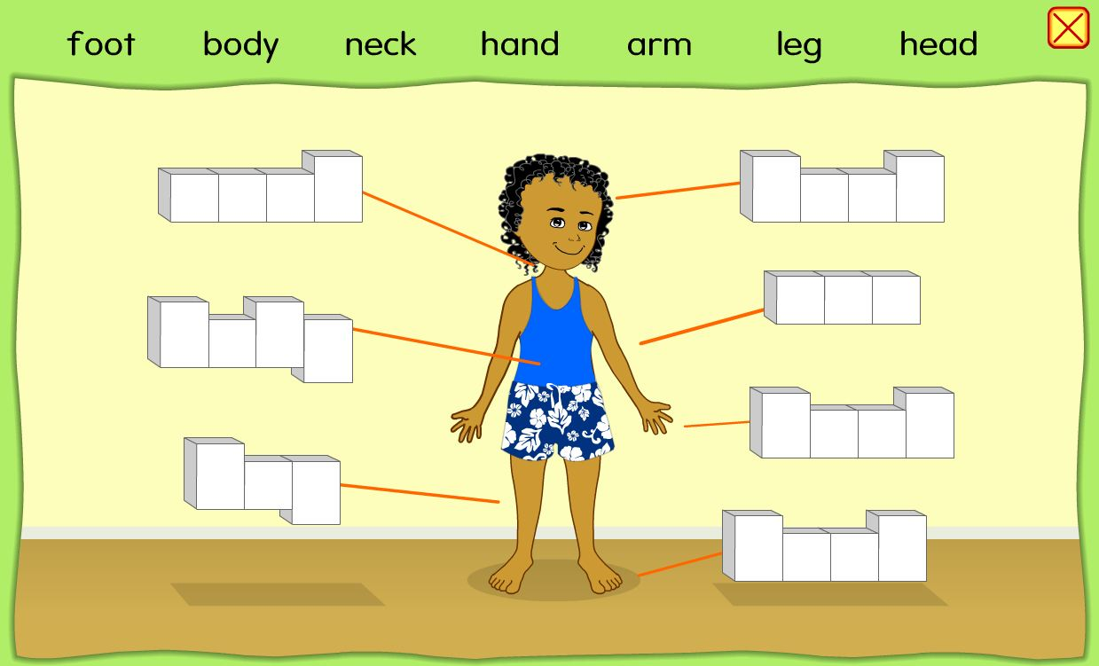

- .

- Match the words with groups.
- Head, toes, fingers, teeth, legs, foot,
- Arms, eyes, nose, mouth, elbow chin

ONE | TWO | THREE OR MORE

- GRAMMAR
Answer the questions with short answers.
Ex: A: Have you got a car? B: Yes, I have
- Have you got a school bag?
_______________.
- Have you got any sisters?
_______________.
- Have you got historical places in Diyarbakır?
_______________.
- Has Messi got strong legs?
_______________.
- Has Shakira got a beautiful voice?
_______________.
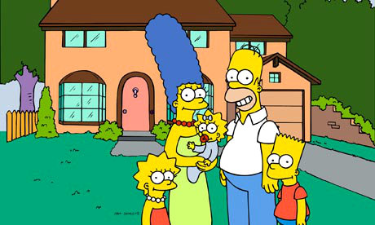
Look at the picture and answer the questions about SIMPSONS.

- How many children have Simpsons got?
________________________________.
- Have they got a garden?
________________________________.
- What have they got in the garden?
________________________________.
Has Homer got any hair?
- ________________________________.

- WRITING

- Write a paragraph about your body like in the reading part.

___________________________
______________________________________________________________________________________________________________________________________________________________________________________________________________________________________________________________________________________________________________________________________________________________________________________________________________________________________________________________________________________________________________________________________________________________________________________________________________________________________________________________________________________________________________________________________________________________________________________________________________________________________________ .

- Write a paragraph about your house.

___________________________
______________________________________________________________________________________________________________________________________________________________________________________________________________________________________________________________________________________________________________________________________________________________________________________________________________________________________________________________________________________________________________________________________________________________________________________________________________________________________________________________________________________________________________________________________________________________________________________________________________________________________________ .

- TEST

- Has Mona _____ a fat cat?
A) has got B) got
C) have got D) is

- ____your father _____ any brothers?
A) Has / have B) ‘s got
C) Has / got D) ‘ve got

- A: ___ your sister got any son?
B: No, she ______ any children.
A) haven’t/ got B) Has/hasn’t got
C) hasn’t/ got D) Have/haven’t got

- A: _____ John and Jill got a ball?
B: No, they ________
A) Have / hasn’t got B) Has / hasn’t
C) Have / has D) Have / haven’t

- There aren’t any bananas in the basket, but ____ we ______ any apples?
A) has / got B) have / got
C) haven’t / got D) hasn’t / got

- ___you___ any water in the glass?
A) Have / got B) got
C) Has / got D) is / got

- A: ______ you _____any children?
B: No, we _______.
A) Has/ have /got B) Have/ got /have got
C) Has/has /got D) Have / got / haven’t

- ____Chris and Ted ___ a bike?
A) have/ got B) has /has
C) have /have D) has / got

- A: Have you got any friend?
B: No, I _______.
A) haven’t B) hasn’t
C) has D) have

- Sue: _____ Anna ____ any money?
Joe: No, she hasn’t.
A) haven’t /got B) hasn’t / got
C) have/ got D) has /got

- On my head I have got _______.
A) foot B) arms
C) hair D) legs

- I speak with my _____.
A) eyes B) nose
C) mouth D) face

- I hear with my ________.
A) nose B) ears
C) foot D) back

- I run with my _______.
A) head B) arms
C) hands D) foot

- I dance with my _________.
A) body B) eyes
C) toes D) nails

Read the text and answer the questions.

Dogs

Dogs are the best animals for the people. They are good friends. They protect us. They are so loyal to their owners. Dogs have got four legs. They can run fast and they can smell very well. In any danger they risk their life for the people. People are so lucky to have them.

- Dogs are good friends.
A) True B) False

- Dogs haven’t got a good nose.
A) True B) False

- Dogs don’t risk their life for people.
A) True B) False

- Dogs have got four legs.
A) True B) False

- People are lucky to have dogs.
A) True B) False

- ANSWER KEY

A-READING

- Look at the picture and guess what is the text about!
- body b) colours c) life

- Answer the questions.
- Has Robin got blue eyes?
Yes, he has.
- Is his head big or small?
His head is big.
- Has he got small ears?
No, he hasn’t.
- Has he got a big mouth?
Yes, he has.
- What is interesting with his body?
He has got six toes on his right foot.

B-VOCABULARY
-Fill the boxes with words.

Neck Head
Body Arm
Leg Hand
Foot

-Match the words with groups.
- Head, toes, fingers, teeth, legs, foot,
- Arms, eyes, nose, mouth, elbow chin
ONE  Head  Chin  Mouth  Nose | TWO  Arms  Legs  Elbow  Foot  Eyes | THREE OR MORE  Teeth  Toes  Fingers

C-GRAMMAR

-Answer the questions with short answers.
Ex: A: Have you got a car?
B: Yes, I have
- Have you got a school bag?
Yes, I have. / No, I haven’t.
- Have you got any sisters?
Yes, I have. / No, I haven’t.
- Have you got historical places in Diyarbakır?
Yes, we have.
- Has Messi got strong legs?
Yes, he has.
- Has Shakira got a beautiful voice?
Yes, she has.

-Look at the picture and answer the questions about SIMPSONS
- How many children have Simpsons got?
They have got three children.
- Have they got a garden?
Yes, they have.
- What have they got in the garden?
They have got some trees and grass.
- Has Homer got any hair?
Yes, he has.

E-TEST ANSWERS

- B
- C
- B
- D
- B
- A
- D
- A
- A
- D
- C
- C
- B
- D
- A
- A
- B
- B
- A
- A

