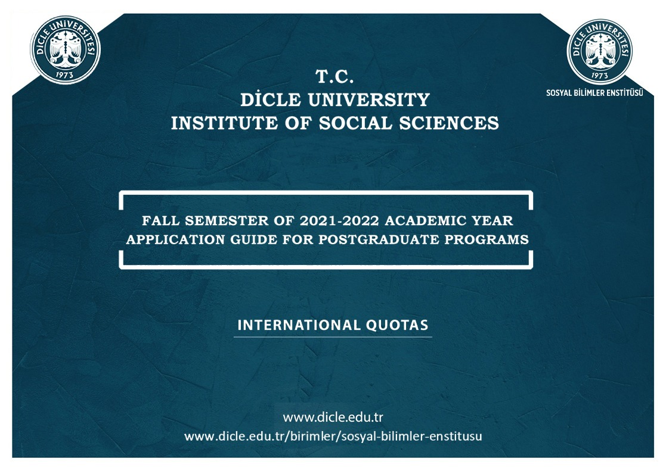

INSTITUTE OF SOCIAL SCIENCES

In the Fall Semester of the 2021-2022 academic year, students will be admitted to our institute for the following graduate programs.
Applications for the postgraduate programs at our institute will be made according to the principles set forth in this guide. In order for the application and registration procedures to be carried out accurately and quickly, the application guide must be carefully examined and all the requirements must be completely done.
In the Fall Semester of the 2021-2022 academic year, the application procedures of international quotas for the programs at our institute will be made online within the application dates.
DIRECTORATE of SOCIAL SCIENCES INSTITUTE

INSTITUTE OF SOCIAL SCIENCES

IMPORTANT DATES FOR APPLICATION AND REGISTRATION PROCEDURES
ACTIVITY | START DATE-DUE DATE
1. Application | 23.08.2021 - 27.08.2021  (08.00) – (23.59)
2. Announcement of Preliminary Evaluation Results (Candidates will follow preliminary assessment results from the system) | 31.08.2021
3. Announcement of Evaluation Results | 06.09.2021
4. Appeal and Evaluation for Mistakes of Fact | 06.09.2021 - 07.09.2021
5. Exact Registration Dates for the Main Candidates (Objections will be made by e-mail to sobe@dicle.edu.tr) | 08.09.2021 - 10.09.2021
6. Registration Dates for the Replacement Candidates who are Eligible for Registration (within working hours) | 14.09.2021 - 16.09.2021
Applications will be taken online between the dates stated above in this link: http://obs.dicle.edu.tr/oibs/enstitubasvuru/login.aspx No application in person or by mail will be accepted.
PLEASE carefully review the on-screen information about the application processes.
Final registration will be taken online via OBS.
If there are any vacancies after registration, placement will be made according to the automation score ranking until 23.09.2021. Please follow your automation application page instantly

INSTITUTE OF SOCIAL SCIENCES

BE WARNED
- Applications made by mail are not accepted.
- All applications are to be made online.
- All the required documents, except photographs, must be uploaded to the system as a pdf file during the application.
- Applications must be made according to the prerequisites stated in the 2021-2022 Fall Semester quota tables. The applications of the candidates who have not applied in accordance with the prerequisites will be canceled.
- During the application, entries of grade point averages must be done according to 100-point grading scale or 4-point grading scale. The candidates who have both the grade point average of 100 and 4 in their transcript must use the grade point average in the e-Government (e-devlet) system as a base. For other grading systems, YÖK (Council of Higher Education) grade conversion table must be used. The entered grade point average will be checked through YÖKSİS.
- The candidates can apply for only one of the Master's and doctoral programs with thesis in Turkish and Arabic.
- Except for Master's programs without thesis, one cannot be registered for and educated in more than one graduate program.
- The students accepted to other programs within the scope of this article, except for the programs in which education and training is conducted entirely in a foreign language, must pass the Turkish language examination of the language centers at the Turkish universities or Yunus Emre Institute.
- Those who have failed must attend the Turkish language course of Dicle University Language Teaching Application and Research Center (TÖMER) for a maximum of a year and they must pass the Turkish exam and successfully complete the course with at least C1 level. Otherwise, the student will be dismissed from the institute. The course duration is not counted as a part of the formal education period.
- The language proficiency of the students admitted according to this article to the graduate programs, in which education is conducted partially or completely in a foreign language, is evaluated in accordance with the provisions of the relevant directive determined by the University.
- The provisions of Dicle University Graduate Education and Exam Regulations are administered for the issues not mentioned in this Guide.
- Those who have made misstatements /false statements and those who have submitted forged documents with defects or distortions or documents that do not meet the criteria of the department will be left out of assessment at any stage of the application evaluation.
INSTITUTE OF SOCIAL SCIENCES

D. INTERNATIONAL QUOTAS

D1. TURKISH PROGRAMS AND INTERNATIONAL QUOTAS
D2. ARABIC PROGRAMS AND INTERNATIONAL QUOTAS
D2.1. ARABIC PROGRAMS AND INTERNATIONAL TRANSFER QUOTAS

INSTITUTE OF SOCIAL SCIENCES

D. INTERNATIONAL QUOTAS FOR MASTER DEGREE
D1. TURKISH PROGRAMS AND INTERNATIONAL QUOTAS
Department | International  Quotas | Prerequisites
ARCHEOLOGY | 5 | The applicants must hold a BA degree in Archeology, Classical Archeology, Protohistoric and Pre-Asian Archeology, Prehistoric Archeology.
CONTEMPORARY TURKISH DIALECTS AND LITERATURE DEPARTMENT | 3 | The applicants must hold a BA degree in Contemporary Turkish Dialects and Literature.
ECONOMICS | 5 | The applicants must hold a BA degree from Faculty of Economics and Administrative Sciences, Faculty of Economics, Faculty of Business Administration or Faculty of Political Sciences.
BUSINESS | 10 | The applicants must hold a BA degree from Faculty of Economics and Administrative Sciences, Faculty of Economics, Faculty of Business Administration, Industrial or Management Engineering Departments of Engineering Faculties or School of Aviation.
SOCIOLOGY | 1 | The applicants must hold a BA degree in Sociology, Philosophy, Anthropology, , Public Administration and Politics, Social Services.
HISTORY OF MODERN AGE | 3 | The applicants must hold a BA degree in History Teaching (Faculty of Education) and History or Archive and Documentation (Faculty of Letters).
TURKISH LANGUAGE AND LITERATURE | 3 | The applicants must hold a BA degree in the relevant Turcology department

INSTITUTE OF SOCIAL SCIENCES

TERMS OF APPLICATION
1. The foreign or Turkish citizen candidates who completed their entire undergraduate or graduate study abroad can apply for the aforementioned programs.
2. It is a requirement that the applicants have completed their undergraduate / graduate study at the universities whose equivalence is accepted or recognized by YÖK (Council of Higher Education)
3. The candidates are NOT required to submit the scores of ALES exam (Academic Personnel and Postgraduate Education Entrance Exam) or a foreign language exam.
4. The Candidates must have at least 65/100 BA grade point average for Master's with thesis programs.
EVALUATION
* There is no evaluation examination for foreign quotas.
- Cumulative grade point average (CGPA)/ undergraduate diploma grade is used as pass grade for Master's with thesis. The pass grade for doctorate consists of the sum of 50% of CGPA/ /undergraduate diploma grade and 50% of CGPA / master's diploma grade. The candidates' pass grades are listed starting from the highest grade and as many candidates as the announced quotas are accepted to the programs. If the candidates have an equal pass grade, then the candidate whose graduation date is new preferred, and if the equality continues, the younger candidate and the candidate whose application date is earlier are preferred respectively.
DOCUMENTS TO BE UPLOADED TO ONLINE APPLICATION SYSTEM
1. The undergraduate diploma for Masters with thesis programs.
2. The undergraduate transcript for Masters with thesis (with the associate transcript if the undergraduate degree has been completed after its integration into the associate degree).
- Those candidates who have completed their entire undergraduate / graduate study abroad are required to upload their undergraduate diploma and transcript to the system to apply for Master's with thesis programs. As for the application of doctorate programs, they are required to upload their undergraduate and graduate diplomas and transcripts coupled with their Turkish translation that is either notarized or approved by Turkish foreign representatives.
- Those candidates with the nationality of the Republic of Turkey who have completed their entire undergraduate / graduate study abroad are required to upload to the system the certificate of equivalence obtained from the Council of Higher Education along with their diploma.
- The foreign candidates who have completed their undergraduate study in a country other than Turkey are required to submit the Certificate of Turkish Language if they have any.
- The candidates with the nationality of the Republic of Turkey are required to submit the military service document (the documents obtained from e-government e-devlet are also valid).
- The foreign candidates must submit the photocopy of their passport or photo identity card; and the candidates who are the citizens of the Republic of Turkey must submit the photocopy of their identity card with T.C. ID number / the photocopy of their identity card.
- The candidate must submit a headshot photo (taken within the last six months)

INSTITUTE OF SOCIAL SCIENCES

D. INTERNATIONAL QUOTAS FOR PhD DEGREE
D1. TURKISH PhD DEGREES AND INTERNATIONAL QUOTAS
Department | International  Quotas | Prerequisites
ECONOMICS | 5 | The applicants must hold an MA with thesis degree from the Department of Economics, Business, Finance, Econometrics or Public Administration.
BUSINESS | 5 | The applicants must hold a MA degree from Faculty of Economics and Administrative Sciences, Faculty of Economics, Faculty of Business Administration.
KURDISH LANGUAGE AND CULTURE  (KIRMANJI) | 3 | The applicants must hold an MA with thesis degree from the Kurdish, Kurdish Language and Culture.
TURKISH LANGUAGE AND LITERATURE | 3 | The applicants must hold a MA degree in the relevant Turcology department

INSTITUTE OF SOCIAL SCIENCES

TERMS OF APPLICATION
1. The foreign or Turkish citizen candidates who completed their entire undergraduate or graduate study abroad can apply for the aforementioned programs.
2. It is a requirement that the applicants have completed their undergraduate / graduate study at the universities whose equivalence is accepted or recognized by YÖK (Council of Higher Education)
3. The candidates are NOT required to submit the scores of ALES exam (Academic Personnel and Postgraduate Education Entrance Exam) or a foreign language exam.
4. The Candidates must have at least 65/100 BA grade point average for Master's with thesis programs, 75/100 MA grade point average for doctoral programs.

EVALUATION
* There is no evaluation examination for foreign quotas.
Cumulative grade point average (CGPA)/ undergraduate diploma grade is used as pass grade for Master's with thesis. The pass grade for doctorate consists of the sum of 50% of CGPA/ /undergraduate diploma grade and 50% of CGPA / master's diploma grade. The candidates' pass grades are listed starting from the highest grade and as many candidates as the announced quotas are accepted to the programs. If the candidates have an equal pass grade, then the candidate whose graduation date is new preferred, and if the equality continues, the younger candidate and the candidate whose application date is earlier are preferred respectively.

DOCUMENTS TO BE UPLOADED TO ONLINE APPLICATION SYSTEM
1. Undergraduate diploma and the postgraduate diploma for doctorate,
2. The undergraduate and postgraduate transcripts for doctorate (with the associate transcript if the undergraduate degree has been completed after its integration into the associate degree).
- Those candidates who have completed their entire undergraduate / graduate study abroad are required to upload their undergraduate and graduate diplomas and transcripts coupled with their Turkish translation that is either notarized or approved by Turkish foreign representatives.
- Those candidates with the nationality of the Republic of Turkey who have completed their entire undergraduate / graduate study abroad are required to upload to the system the certificate of equivalence obtained from the Council of Higher Education along with their diploma.
3. The foreign candidates who have completed their undergraduate study in a country other than Turkey are required to submit the Certificate of Turkish Language if they have any.
4. The candidates with the nationality of the Republic of Turkey are required to submit the military service document (the documents obtained from e-government e-devlet are also valid)
5. The foreign candidates must submit the photocopy of their passport or photo identity card; and the candidates who are the citizens of the Republic of Turkey must submit the photocopy of their identity card with T. C. ID number / the photocopy of their identity card.,
6. The candidate must submit a headshot photo (taken within the last six months).

INSTITUTE OF SOCIAL SCIENCES

D.2. ARABIC PROGRAMS
INTERNATIONAL QUOTAS
MASTER’S WITH THESIS
Department | Quotas | Prerequisites
BASIC ISLAMIC SCIENCES  (ARABIC) | 6¹ | The candidates are required to have graduated from the faculties offering at least four years of formal undergraduate study that is recognized by YÖK ( Council of Higher Education) such as the Faculty of Theology / Islamic Sciences, Faculty of Sharia (Külliyetu'ş-Şeri), Islamic Studies (Dirasatu'l İslamiyye), Religious Law (Usulu'd-Din) or equivalent faculties.
¹ Distribution of quotas according to disciplines: Tefsir 2, Arabic Language and Rhetoric 2, Tasavvuf (Islamic Mysticism) 2.
DOCTORATE
Department | Quotas | Prerequisites
BASIC ISLAMIC SCIENCES  (ARABIC) | 4¹ | The applicants must hold a BA degree from Faculty of Theology / Islamic Sciences, Arabic Language and Literature, Iranology, Faculty of Sharia (Külliyetu'ş-Şeri'a), Islamic Studies (Dirasatu'l İslamiyye), Religious Law (Usulu'd-Din) or equivalent faculties that offer at least four years of formal education as well as holding an MA with thesis degree from Basic Islamic Sciences, Arabic Language and Literature or programs that teach Arabic Language.
¹ Distribution of quotas according to disciplines: Tefsir 2, Arabic Language and Rhetoric 1, Tasavvuf (Islamic Mysticism) 1.

INSTITUTE OF SOCIAL SCIENCES

D.2. ARABIC PROGRAMS AND INTERNATIONAL QUOTAS

TERMS OF APPLICATION
1. The foreign or Turkish citizen candidates who completed their entire undergraduate or graduate study abroad can apply for the aforementioned programs.
2. The candidates are NOT required to submit the scores of ALES exam (Academic Personnel and Postgraduate Education Entrance Exam).
3. The candidates are NOT required to submit the score of a foreign language (Arabic) exam.
4. The Candidates must have at least 65/100 BA grade point average for masters with thesis programs, 65/100 BA grade point average and at least 75/100 MA grade point average for doctoral programs.
5. The applicants are required to have obtained their diplomas from the universities whose equivalence is accepted or recognized by YÖK (Council of Higher Education).

EVALUATION
* There is no evaluation examination for foreign quotas.
a) Cumulative grade point average (CGPA)/ undergraduate diploma grade is used as pass grade for master's with thesis.
b) The pass grade for doctorate consists of the sum of 50% of CGPA/ /undergraduate diploma grade and 50% of CGPA / master's diploma grade. The candidates' pass grades are listed starting from the highest grade and as many candidates as the announced quotas are accepted to the programs. If the candidates have an equal pass grade, then the candidate whose native language is Arabic, whose undergraduate study was in Arabic, whose graduation date is newer, who is younger and whose application date is earlier are preferred respectively.

The language proficiency of the candidates applying for the international quotas of Arabic programs
The language proficiency of the students admitted according to this article to the graduate programs, in which education is conducted partially or completely in a foreign language, is evaluated in accordance with the provisions of the relevant directive determined by the University.

INSTITUTE OF SOCIAL SCIENCES

DOCUMENTS TO BE UPLOADED TO ONLINE APPLICATION SYSTEM
1. The undergraduate diploma for masters with thesis programs, undergraduate diploma and the postgraduate diploma for doctorate,
2. The undergraduate transcript for masters with thesis (with the associate transcript if the undergraduate degree has been completed after its integration into associate degree), the undergraduate and postgraduate transcripts for doctorate (with the associate transcript if the undergraduate degree has been completed after its integration into associate degree).
- Those candidates who have completed their entire undergraduate / graduate study abroad are required to upload their undergraduate diploma and transcript to the system to apply for master's with thesis programs. As for the application of doctorate programs, they are required to upload their undergraduate and graduate diplomas and transcripts coupled with their Turkish translation that is either notarized or approved by Turkish foreign representatives.
- Those candidates with the nationality of the Republic of Turkey who have completed their entire undergraduate / graduate study abroad are required to upload to the system the certificate of equivalence obtained from the Council of Higher Education along with their diploma.
3. The candidates whose native language or language of their undergraduate study is Arabic are required to upload to the “Documents” section in the application system a certificate confirming that their native language or language of their undergraduate study is Arabic.
4. The candidates with the nationality of the Republic of Turkey are required to submit the military service document (the documents obtained from e-government/e-devlet are also valid)
5. The foreign candidates must submit the photocopy of their passport or photo identity card and the candidates who are the citizens of the Republic of Turkey must submit the photocopy of their identity card with T. C. ID number / the photocopy of their identity card.,
6. The candidate must submit a headshot photo (taken within the last six months).

INSTITUTE OF SOCIAL SCIENCES

DOCUMENTS REQUIRED FOR EXACT REGISTRATION PROCEDURES

Those candidates who are entitled to the exact registration must submit the documents written below to the relevant institute directorate personally or through their official attorney (or electronically upon a request by the Institute due to the pandemic conditions) within the announced period:
1. The undergraduate diploma for the application of Master's with thesis programs, undergraduate diploma and the postgraduate diploma for the application of doctoral programs or their notarized or approved copy by the relevant higher education institution.
2. The Turkish translation, notarized or approved by a Turkish foreign representative, of the diploma of the candidates graduating from a higher education institution abroad.
3. The Turkish translation of the diploma of the candidates graduating from higher education institutions abroad, approved by a notary public or a Turkish foreign representative.
4. A certificate of equivalence, obtained from the Council of Higher Education, of the candidates with the citizenship of the Republic of Turkey completing their undergraduate / postgraduate education abroad.
5. A notarized or certified copy of the transcript documents showing the grade point average and graduation grade of all the courses taken throughout undergraduate and graduate education.
6. The candidates graduating from a higher education institution abroad must submit their transcript document containing GPA along with its Turkish translation.
7. 2 passport size photographs (4,5x6 cm) taken within the last six months from the front in a way that can easily identify the candidate.
8. The copy of the identity card (The copy of the residence permit and the document showing the foreign national number for foreign nationals).
9. The notarized Turkish translation of the pages showing the identity information and validity period of the passport with student visa for foreigners. (A Student Visa will not be required at the time of registration from those who certify that they have a valid residence permit).
10. The original copy of the newly date Military Status Document of the male candidates taken from the military branches (it will not be requested from foreign candidates). For international students, the "Turkish Proficiency" document certifying that they know Turkey Turkish.
11. The bank receipt showing that the student contribution fee / tuition fee has been paid. (The foreign national candidates and the Turkish candidates residing abroad and applying for international quotas are obliged to pay the tuition fee).

INSTITUTE OF SOCIAL SCIENCES

CONTACT AND APPLICATION ADDRESS

APPLICATION ADDRESS
https://obs.dicle.edu.tr/oibs/ina_app/

CONTACT
Social Sciences Institute’s web address: http://www.dicle.edu.tr/sosyal-bilimler-enstitusu

Land Line: 0412 241 10 10 Extension: 8455/8480/8487

